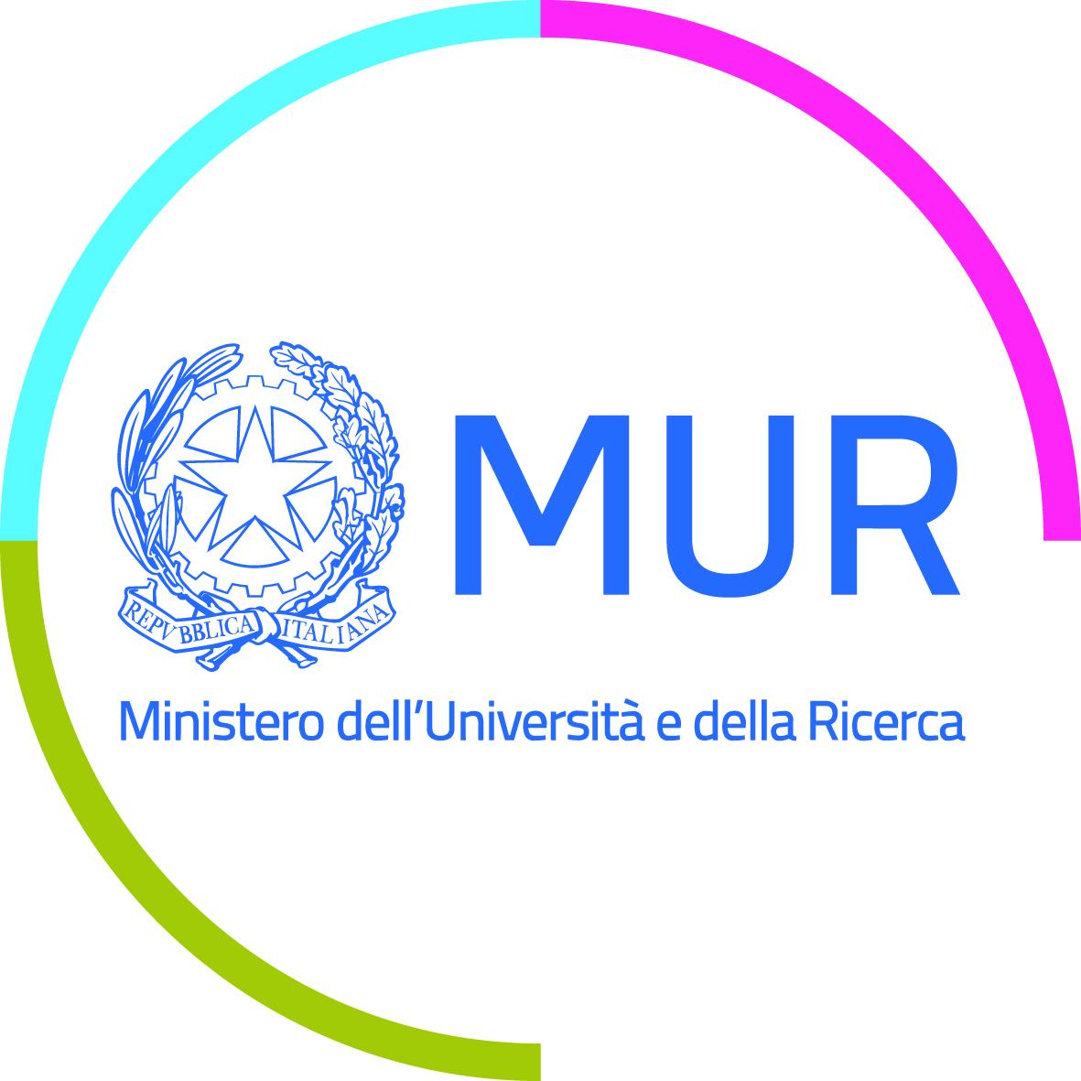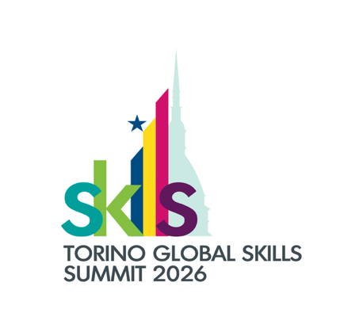

START CUP COMPETITION 2026

DRAFT AGENDA

Turin, 23-24 November 2026 Hosted by the European Training Foundation (ETF) In the framework of the Torino Global Skills Summit

23 November 2026
08.45 - 16.45
Venue: European Training Foundation Venue: Viale Settimio Severo 65 Torino
Google Maps link:

Moderators: Silvia Marchionne (UNIMED) & Lynda Achkouty (UNIMED SubNetwork on Employability)
08.45 09.15 Arrival, welcome coffee and registration
09.15 – 09.30 Posters “Exhibition”
9:30-9:35 OPENING SESSION
Welcome note by Mrs Silvia Marchionne, UNIMED Senior Manager
9:35-10.00 Institutional greetings and welcome
Pilvi TORSTI, Director of the European Training Foundation – ETF (TBC)
Marcello SCALISI, UNIMED Director
Sélim MEKDESSI, Dean of the Faculty of Economics and Business Administration, Lebanese University and Coordinator of the UNIMED SubNetwork on Employability
Nathalie BITAR, Deputy Director of Projects, AUF Middle East Regional Office (online) - TBC
Damiano PETRUZZELLA, Lead for Innovation & Knowledge Transfer, at CIHEAM - CIHEAM Bari (International Centre for Advanced Mediterranean Agronomic Studies) (online) - TBC
10:00 - 10.15 Keynote speaker from European Training Foundation
10.15 – 10:30 Presentation of the selected teams and of the Start Cup jury members
By Silvia Marchionne (UNIMED) & Lynda Achkouty (UNIMED SubNetwork on Employability)
10:30-11:00 Group picture and Coffee break
11:00 – 12:30 PITCH – Q&A Round 1
(Up to 10 minutes per team, 3 minutes itch, 5 minutes Q&A, 2 minutes to shift from a team to another)
- An-Najah National University, Palestine - OliveStone
- Sulaimani Polytechnic University, Iraq - BioPack Agro
- Université Euro-Méditerranéenne de Fès UEMF, Morocco - Alwarid
- Lebanese University, Lebanon – VerdePlastix
- Tishk International University, Iraq – HoloMed AI
- Nova University Lisbon, Portugal – Nsafe
- Palestine Technical University Khadoorie, Palestine - EcoCool
- Al-Ahliyya University Amman, Jordan – Care Connect

12:30-13:30 Lunch
13:30-14:00 Slot dedicated to ITC-ILO & the enterprise VANNI
Monica LISA, Senior Programme Officer, Learning Innovation Programme, Strategic Facilitation Lead, International Training Center of the ILO
Alessandra GIRARDI, Vice-President of Excellence Brands Torino and owner of enterprise VANNI
14.00 – 15:30 PITCH – Q&A Round 2
- Seiyun University, Yemen - Virtual Accountant “Luca Pacioli”
- Erbil Polytechnic University, Iraq – RNF Solutions
- Palestine Polytechnic University, Palestine - MycoCicle
- University Abderrahmane-Mira of Béjaïa, Algeria – PatrimiIA
- Libyan International University, Libya - Smart Solar Bio Box
- Manisa Celal Bayar University, Türkiye
- University of Tunis, Tunisia - Jean Z
- Hebron University, Palestine - CrisisLink
15:30-16:00 JURY DELIBERATION

16:00-16:30 CONCLUSION by Silvia Marchionne & Lynda Achkouty

Announcing the winner

- Selected by the jury based on the scoring
- Selected by the attendees
16:30 end of Start Cup Competition and transfer to the hotel

18.15 Transfer from the hotel to OGR for the award ceremony

19.00 – 21.30 – Official award ceremony and cocktail dinner
(Venue: OGR Corso Castelfidardo, 22 - 10128 - Torino (TO))

TORINO GLOBAL SKILLS SUMMIT
24 November 2026
09.00 - 17.00
OGR, Torino
Google Maps link:

09:00 - 09:30 Welcome
09:30–10:15 Skills, Europe and geopolitical challenges
Why skills matter for Europe’s competitiveness, security and cooperation with its partners

10:15 - 11:00 From near and far: international perspectives on skills Shared challenges and what is needed from international cooperation on skills.

11:00 - 11:15 What it takes to make a difference ETF Director Pilvi Torsti in conversation with influencers from across the regions
11:15 - 11:45 Coffee break and networking
11:45 - 12:30 “Skilling me softly”: connecting people, business and society Setting the scene for the discussions ahead

12:30 - 14:00 Lunch break and networking opportunity

15.00 - 17.00 Visit to the I3P – Incubator for Innovative Enterprises of Polytechnic University of Turin

