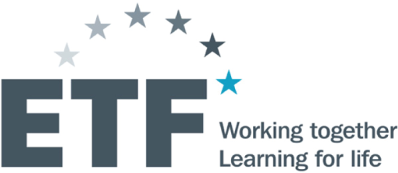
Evidence-based policy making with focus on youth transition from school to work, skills development and social integration

2 July 2020 (10.30-12.20 CET)
Online Event on ZOOM Platform

Background
The countries of the South East Europe and Turkey (SEET) pursue various reforms aimed at making education and training more sensitive to the needs of learners and companies and boosting the effectiveness of employment and social integration actions.
A solid evidence-based design and implementation of policies require a wide range of data sources and types of indicators. Over the last decade the SEET countries have consolidated their statistical research instruments and practices (survey or administrative based), and secured comparability with the EU statistical standards. Measuring the effects education, activation and social integration remains a challenging aspect in the policy making.
Integration of the young people in employment and provision of skills relevant for the current and future labour market needs is a recurrent priority for the SEET countries, as well as for the EU Member States. COVID-19 triggered economic downturn adds up to an already difficult entry of young people in the labour market, particularly among groups with vulnerable socio-economic background.
On this backdrop, the European Training Foundation (ETF) initiated a research action focused on transition from school to work and labour market integration of young people through more responsive skills development, employment and social inclusion measures. A component of this action looked at the potential to innovate in the area of evidence (i.e. data and information based on both quantitative and qualitative methods) and its policy use.
The main objective of this online event is to present the preliminary findings in the area of indicators and methodological underpinnings, including the main lessons of the country case – Serbia – on possible areas of innovation with regards to youth specific indicators. The following types of evidence shall be discussed: education outcomes and transition from school to work, skills utilization such as skills mismatch, forecast of future trends in supply and demand with specific focus on younger cohorts and social inclusion and poverty dimension of labour market activation.
Key topics
- Overview of ETF work on data gathering, availability, quality and potential for further development in the region;
- New indicators on youth situation, with focus on skills, labour market and social vulnerabilities.
The event will include a discussion on the potential for further development and priorities in the area of indicators for policy design and monitoring, including IPA programming.
Target participants: Statisticians, data analysts and experts from the statistical offices, education and labour ministries and/or agencies of the SEET countries, EU Delegations or offices in the SEET, European Commission, EU agencies, regional and international organisations

Agenda

10:30 – 10:35 – Welcome
Xavier Matheu de Cortada, Head of Policy Unit, ETF

10:35 – 10:40 – Introduction on ETF’s youth work in the region of South East Europe and Turkey – milestones and outputs
Cristina Mereuta, Labour Market Specialist, ETF

10:40 – 11:00 – Building evidence on education, skills, employment and human capital: the ETF approach
Mircea Badescu, Statistician and Data Analyst, ETF

11:00 – 11:20 – Country case Serbia: Data sources and indicators fit to capture youth vulnerabilities
Gorana Krstic, Full Professor, Faculty of Economics, University of Belgrade / Foundation for the Advancement in Economics (FREN), Serbia

11:20 – 11:30 Questions and answers

11:30 – 12.10 Discussion/Exchanges on priorities and needs for the consolidation of the evidence base in the area of skills, employment and social policies with focus on youth
National, regional, European and international stakeholders

12:10 – 12:20 Conclusions and closure of the event
Ulrike Damyanovic, Country Coordinator for Montenegro, Focal Point for South Eastern Europe and Turkey, ETF

