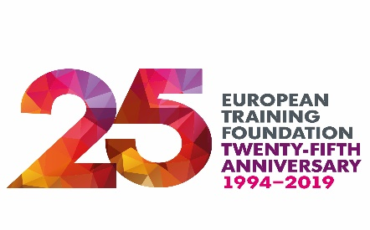
Education, training and skills are key to economic growth, social cohesion and political stability in EU neighbourhood countries
European Training Foundation – The Power of Skills in EU External Relations, Wednesday 20 November, Brussels
Torino, 19 November 2018
Cesare Onestini, Director of the European Training Foundation (ETF), has highlighted the vital role of education, training and skills in economic growth, social cohesion and political stability in EU neighbourhood countries.
Speaking in advance of The Power of Skills in EU External Relations, which is being held in Brussels on 20 November to mark the ETF’s 25th anniversary, Cesare Onestini commented:
“Over the last 25 years, the ETF has supported over 40 countries in modernising their education, training and labour market systems. Thirteen of them are now members of the European Union and another seven are at different stages on the path towards EU accession. This testifies to the power of skills to create opportunities for people, underpin inclusive economic and social development and lay the foundations for stability and prosperity in the EU’s partner countries. Something that is in our interest as much as it is in theirs”
“The ETF was created in the aftermath of the fall of the Berlin wall to help the newly liberated countries of Central and Eastern Europe adapt to open markets and democracy. Now global forces of change are transforming the world we live and work in. People of all ages will need to adapt to changing professional and personal roles as they move through life. The ETF’s focus in the coming years will be on supporting countries in building joined-up lifelong learning systems.”
The Power of Skills in EU External Relations
To mark its 25th anniversary, the European Training Foundation is hosting an event focusing on The Power of Skills in EU External Relations on Wednesday, 20 November 2019 18:00-22:00, TownHall Europe, Square de Meeûs 5-6, Brussels.
At the start of a new legislature and with new leadership in Brussels, it’s an important time to consider the role of education and skills in the next generation of EU external relations policies and programmes. The event will gather influencers and decision makers in the field of education, employment, social affairs and development at European and international level.

Ayla Göksel, Chief Executive Officer of the Turkish Non-Governmental Organisation, Özyegin Social Investments, will deliver the keynote speech about the power of education and training in economic and social development in Turkey and 14 other countries in which the organisation is active.

A panel debate will follow with David O’Sullivan, former Commission Secretary General and former EU Ambassador in Washington, Portuguese MEP Margarida Marques, Vice-Chair of the Committee on Budgets and Manuela Geleng, European Commission Director for Skills focusing on the value of education and skills in social and economic development and future implications for the EU external relations policies and programmes.

[ENDS]
Notes to Editors:
The European Training Foundation (ETF) is the EU Agency supporting countries in the EU neighbourhood to undertake reforms in education and training and employment policies. https://www.etf.europa.eu/en
Press registration: If you’d like to attend the event, please reply to caroline.randle@thepr.network
Interview opportunities: Cesare Onestini and Ayla Göksel will be available for interview.
For further information: https://www.etf.europa.eu/en/news-and-events/news/power-skills-eu-external-relations-high-level-panel

Press contacts:
Caroline Randle: caroline.randle@thepr.network + 44 (0)7796 140461
Joanna Anstey: joanna.anstey@etf.europa.eu +39 340 1504506

