Torino Process Award for the Entrepreneurship Key Competence

Why a Torino Process Award for the Entrepreneurship Key Competence?
The Torino Process encourages ETF partner countries to continuously review, improve and innovate their vocational education and training. Entrepreneurship as a key competence features in the Torino Process. ETF promotes understanding and development of entrepreneurship as a key competence in its partner countries including the European Entrepreneurship Competence Framework (EntreComp). The Torino Process Award for the Entrepreneurship Key Competence allows for identification and recognition of good practice in entrepreneurship key competence promotion in vocational education and training.
Who can participate?
The competition is open to all vocational schools or training centres from all ETF partner countries.
How to participate?
Delegates at the Torino Process conference (7-8 June 2017) should register at the Entrepreneurship and Innovation Market (8 June, 9.15-11.30). Delegates will have an opportunity to learn more about EntreComp and which competence areas feature in the competition. Secondly, back home after the conference Torino Process delegates will identify vocational schools or training centres that are promoting competences that feature in EntreComp. Schools or training centres interested in competing in the competition will complete the attached form. The form asks for detail in two areas: a) learning outcomes and a) teaching and learning methods.

Alternatively, schools/training centres can download the application form directly from ETF website (www.etf.europa.eu) and submit to the address below and by the deadline indicated.

Applications using the attached form should be submitted by email by 20 September 2017 to EntreComp@etf.europa.eu .

Selection process
ETF will review all submissions against two criteria a) learning outcomes for the entrepreneurship key competence and b) innovative approaches to teaching and learning. The VET school/training centre with the most inspiring submission will be announced on 22 September 2017.

Award ceremony - European Vocational Skills Week (20-24 November 2017)
A representative of the school, and the Torino Process delegate who helped identify the good practice, will be invited to Brussels. The Torino Process Award for the Entrepreneurship Key Competence will be conferred by Marianne Thyssen, European Commissioner for Employment, Social Affairs and Inclusion on 24 November 2017.

APPLICATION FORM

Torino Process Award for the Entrepreneurship Key Competence
The vocational school/training centre will provide a description of its activities in promoting entrepreneurship key competence as well as details of the staff member to participate at the award ceremony in Brussels on 24 November 2017.

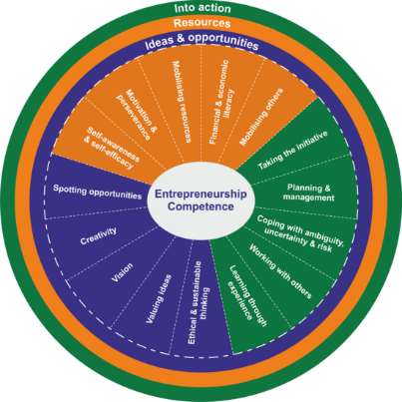

Please, submit the good practice by email to: EntreComp@etf.europa.eu

Deadline: 20 September 2017.

Torino Process Award for the Entrepreneurship Key Competence
The vocational school/training centre will provide a description of its activities in promoting entrepreneurship key competence as well as details of staff member to participate at the award ceremony in Brussels on 24 November 2017.

1. Torino Process Conference Delegate
Name

Country

Organisation

Email

Telephone

2. Details of vocational school or training centre
Name of school

Address

Telephone

Email

Director’s name (or other staff member who will participate in European Vocational Skills Week awards ceremony)

3. Entrepreneurship key competence
Which ‘EntreComp’ competence(s) are developed?

4. How is the ‘EntreComp’ competence(s) developed?
Provide an example(s) of a learning outcome(s) for the competence(s) chosen (max. 100 words)

Describe the teaching and learning approach to achieve the learning outcome(s) (max. 200 words)

Albania, Algeria, Belarus, Armenia, Azerbaijan, Bosnia and Herzegovina, Egypt, Georgia, Israel, Jordan, Kazakhstan, Kyrgyzstan, Libya, Kosovo*, Lebanon, former Yugoslav Republic of Macedonia, Moldova, Montenegro, Morocco, Palestine, Russia, Serbia, Syria, Tajikistan, Tunisia, Turkey, Turkmenistan, Ukraine, Uzbekistan. * without prejudice to positions on status, and in line with UNSCR 1244/1999 and the ICJ opinion on Kosovo’s declaration of independence.

